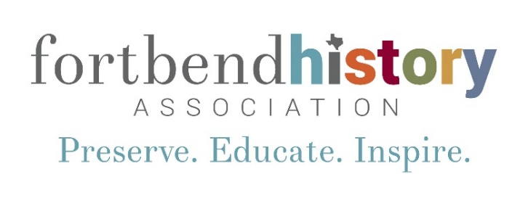

Fort Bend History Association - 2023 Fall Internships

The Fort Bend History Association announces two fall internship opening for 2023. The Fort Bend History Association is an AAM-accredited 501(c) (3) non-profit, tax-exempt corporation chartered in 1967, whose mission is to preserve and interpret Texas and Fort Bend County history. The Association owns and operates the Fort Bend Museum. The Texas Historical Commission, in a published evaluation of historic sites (2001), termed the Fort Bend Museum "one of Texas' best local history showcases.” One internship opportunity will be within Association administration and include projects assisting with marketing and development. The other successful intern candidate will have the opportunity to work in the Fort Bend Museum and assist with projects including, but not limited to, planning and presentation of educational programming, collections care, exhibition development, interpretation research and facilitation, visitor services, and special event coordination over the course of the internship.

Preferred Candidates: Will be a graduate or undergraduate candidate in museum studies, public history, history or communication from an accredited institution, with a focus/interest in museum exhibition, administration, marketing or museum education. Experience working in museums preferred. The Fort Bend History Association would prefer to run the internship roughly from July through December (can be six months or semester length depending on needs of candidate). The Fort Bend Museum’s Chief Curator will work with candidate to establish course credit and meet appropriate requirements. Candidate must have a car while completing the internship.

Work Week: Approximately 40 hours per week, the Administration intern works Monday through Friday while the Museum intern works Tuesday through Saturday

Compensation: Housing will be provided at the Museum’s sister organization, the George Ranch Historical Park. A $100/wk stipend is also available.

Deadline: April 4, 2023

Interested candidates should send a letter of interest indicating which internship they are pursuing, current resume or CV, and the names of 3 references to:

Chris Godbold, Chief Curator
Fort Bend History Association
PO Box 460
Richmond, TX 77406
or cgodbold@fbhistory.org

For additional information, email cgodbold@fbhistory.org.

